Fruit for the Communities - A Time to Sow
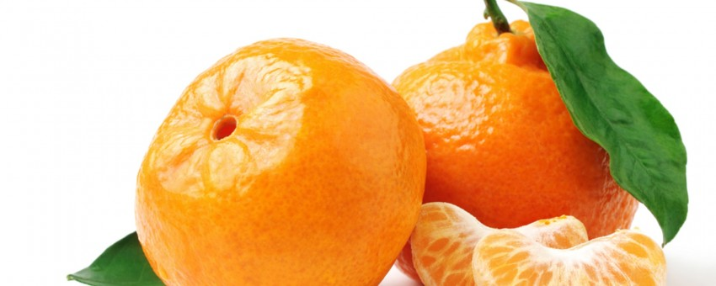
Keep Terrebonne Beautiful has successfully competed for a grant from UPS to plant 140 fruit trees in Terrebonne Parish. The grant was awarded for planting a community garden of fruit trees. Louisiana Sweet oranges, satsumas, figs, and lemons are being provided by a grower. Volunteers from Keep Terrebonne Beautiful, Bayou Grace, Sowing Community Seeds, South Louisiana Wetlands Discovery Center and BTNEP have organized plantings in February at various sites. If you or an organization to which you belong want to assist in the planting or maintenance of these trees, please call Wendy Billiot at 851-7578 or Brenda Babin at 873-0107.
February 11- 6877 Shrimpers Row 9:30 am BTNEP
then 5123 Grand Caillou Road until ~ noon BTNEP
608 Columbus 9:30 Sowing Seeds
February 20- 520 Woodhaven 10:00 UPS
February 24- 1427 Hwy 55 10:00 Bayou Grace
These trees will be planted on Parish owned properties purchased through FEMA buyouts after storm events. When the Parish purchases homes with FEMA funds, the properties must remain in open space use permanently. The Parish has few options for transferring ownership of the land. This project will make use of these properties as productive community gardens.
The fruit will be available to anyone in the community. They will be able to go on site and pick it. The nonprofits, youth groups, or churches may opt to pick the fruit for local schools or food banks in the future.
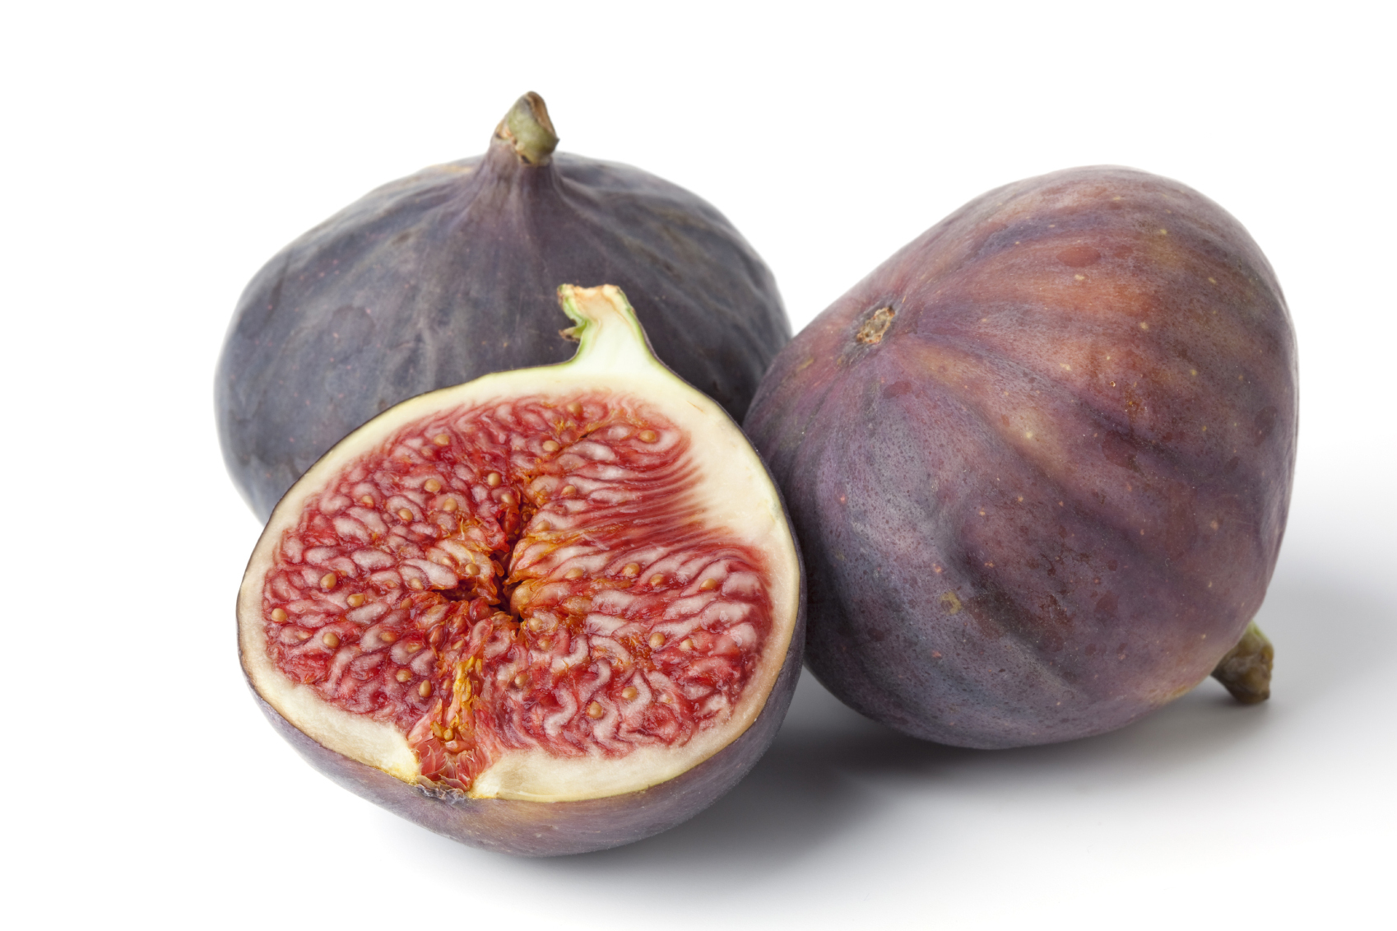
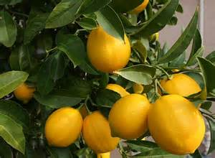
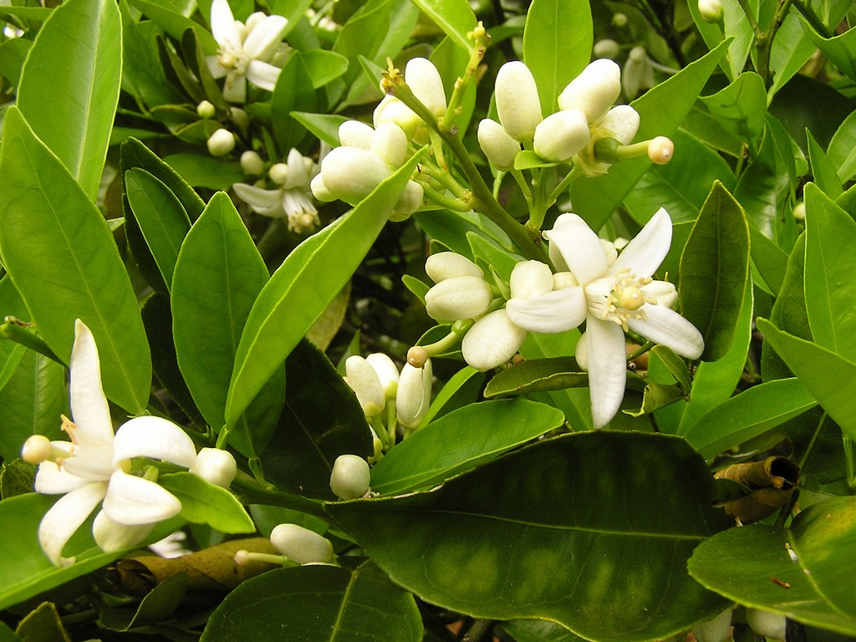
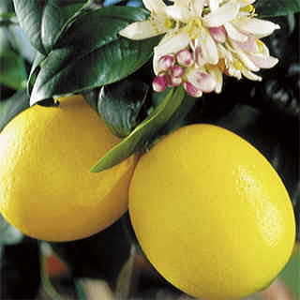
Shovels and all materials will be provided if you do not have your own.

Each participant or observer must sign a waiver of liability for the Parish and nonprofits. BTNEP is also planting sites for bird habitat. Further updates to come.
Call Jennifer Gerbasi in the Planning Department at 873-6565 if your organization is interested in similar activities on parish HMGP properties.

